THIS EXAMINATION CONSISTS OF SEVEN PAGES
PLEASE ENSURE THAT YOU HAVE A COMPLETE PAPER

THE UNIVERSITY OF BRITISH COLUMBIA
PETER A. ALLARD SCHOOL OF LAW

FINAL EXAMINATION – DECEMBER 2022

LAW 422/570C
Intellectual Property Law

Section 1
Jon Festinger, K.C.

TOTAL MARKS: 70

WRITING TIME ALLOWED: 3 HOURS
READING TIME ALLOWED: 15 MINUTES

(9:00 AM PST) READING TIME ALLOWED: 15 MINUTES
(9:15 AM PST) WRITING TIME ALLOWED: 3 HOURS

This is an open book examination, meaning that you can refer to class notes, the course casebook (Canadian Intellectual Property Law: Cases and Materials (3rd or 2nd Ed.)), the course PowerPoint slides, and other class readings. Unless otherwise indicated, assume the applicable laws are the laws of British Columbia and Canada.

You have 15 minutes of reading time. The reading time is in addition to the 180 minutes of writing time. During the reading time, you should only make notes on the question sheet or on the scrap paper. During the reading time, do not write anything that you want marked. The reading time is in addition to the times suggested for each question.

Students writing by hand:
- Please write legibly on every second line of your exam booklet. Write on one side of the page only.
- Do not put your name on the exam booklets. Use only your exam number.
- At the end of the exam, please return all exam booklets, including blank ones. No credit will be given for anything written in a booklet that is removed from the exam room, even briefly.

Do not begin your exam until you are instructed to do so.

Please put your exam code on the question paper and return the question paper at the end of the exam.

This examination consists of TWO (2) questions. THE SECOND QUESTION HAS TWO CHOICES. FOR THE SECOND QUESTION, ANSWER ONLY ONE OF A OR B.

If you think you have discovered an error or potential error in a question on this exam, please make a realistic assumption, set out that assumption clearly in writing, and continue answering the question.

Have a great winter break!

Question 1 [45/70 marks, 120 minutes recommended]:

Cassian Blank is a Vancouver artist. He is a fan of the English artist Banksy.

The first paragraph of the Wikipedia entry for Banksy reads:

“Banksy is a pseudonymous England-based street artist, political activist and film director whose real name and identity remain unconfirmed and the subject of speculation. Active since the 1990s, his satirical street art and subversive epigrams combine dark humour with graffiti executed in a distinctive stenciling technique. His works of political and social commentary have appeared on streets, walls and bridges throughout the world. Banksy's work grew out of the Bristol underground scene, which involved collaborations between artists and musicians. Banksy says that he was inspired by 3D, a graffiti artist and founding member of the musical group Massive Attack.”

Cassian Blank is such a fan of Banksy’s work, he adopts the pseudonym Blanksy for his artistic efforts. For the most part, the Vancouver artistic community comes to know him as Blanksy, not as Cassian Blank.

On Friday October 5, 2018, the auction house Sotheby's sold a Banksy spray-paint-on-canvas painting called “Girl with Balloon” for $1.4 million. The painting was a version of one of Banksy's most famous works, an image of a girl releasing a red balloon. Moments after it sold, more than half of the painting self-destructed by means of an automated remotely controlled paper shredder embedded at the bottom of its thick frame. The stunt is understood as being part of the art itself, coming from the anonymous artist who is known for creating satirical and subversive political art. Banksy quoted the artist Picasso in a subsequent Instagram post: “the urge to destroy is also a creative urge.” Banksy has since said that the incomplete shredding of “Girl with Balloon” was a mechanical malfunction

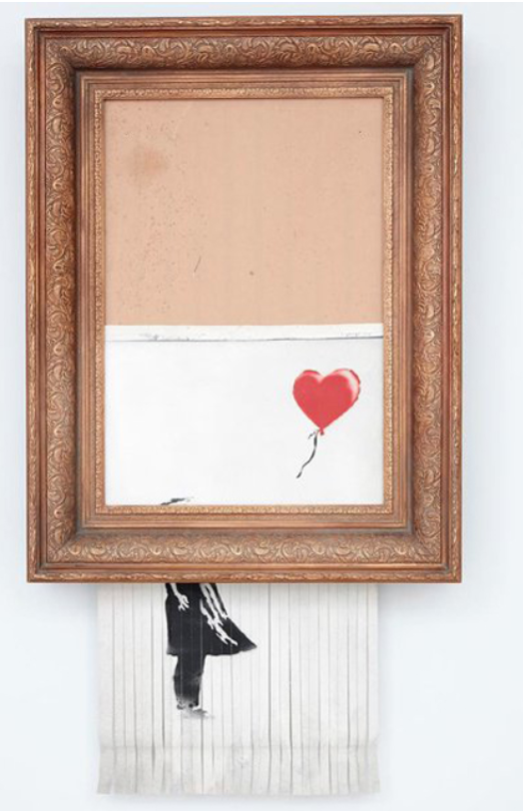

This is a picture of the mostly shredded “Girl With Balloon” illustrating the shredded portions of the artwork protruding below the frame.

On Thursday October 21, 2021, this same semi-shredded artwork, now retitled “Love Is in the Bin”, resold at auction for $25.4 million. There are no surprises at this second auction, except perhaps for the selling price – more than three times the auction house’s top estimate going into the event.

Inspired by Banksy’s actions, the artist formerly known as Cassian Blank, and now known as “Blanksy”, decides to create a computer application that will do something similar in the context of the virtual world of the internet. He creates an “app” that allows any member of the public to
take any visual artistic work on the internet and appear to destroy it. He calls the app “BlanksysArtSchool”.

The first version of the app contained many different destructive modes including virtual shredding, virtual defacement, virtual crumpling, and virtual egg throwing – the latter resulting in what appeared to be raw eggs splattered on the artistic work being attacked. In this first version of the app, the user would copy or take a screenshot of the visual art to be destroyed, paste it into the app, and then choose a method of destruction. In this Version 1.0 of the app, the copy of the artwork would appear to be destroyed by the app. However, only the user of the app would witness the destruction of the artwork. Its destruction had no impact on what anyone else could see on the internet.

The app was free and became quite popular. At first, Blanksy did not hear any objections from the creative community.

In version 2.0 of the “BlanksysArtSchool” app, partial destruction was enabled. Users could choose 25%, 50%, or 75% destruction, though the modes of destruction remained the same as in version 1.0. The only major content change being that the app’s settings could no longer destroy 100% of the virtual work. Also, Version 2.0 and all subsequent versions were no longer free. Version 2.0 cost $20, with version 1.0 no longer being available to download.

Version 3.0 of the app had all the features of version 2.0. Additionally, for version 3.0 Blanksy was able to create a tool that can either permanently deface or partially destroy any work of visual art at the internet source of the art, not just on the User’s computer. The tool incorporates an internet Artificial Intelligence (“A.I.”) “crawler” that searches all versions of the same image on the internet and defaces/partially destroys those versions in an identical manner. In this way, Blanksy created a true metaverse graffiti tool that could permanently alter the appearance of any artwork on the internet. Version 3.0 cost users $30.

In version 4.0, Blanksy decides to extend what can be destroyed to include all commercial marks including trademarks and “get-ups”. Also, this version of the app allows the trademarks and the artistic works to be partially destroyed or altered. This means, for example, that in the case of an artwork depicting a dog, it is possible to replace the dog with a similarly (or dissimilarly) appearing cat. Or, in the case of a consumer brand, it provides the ability to change the trademark for the store “Best Buy” to, for example, “Bad Buy”. It seems Blanksy became furious when reading an article in the Journal of Consumer Psychology called “Art and the brand: The role of visual art in extending brand extendibility”. Blanksy figures that if commercial brands are going to use art in their brand extension strategies, it is only fair to let users let the world know what they think of the brands themselves. Version 4.0 cost users $40.

Blanksy then creates a similar app directed at disrupting music on the internet. The A.I.-powered app crawls the internet for a particular music by an artist chosen by users, and after some A.I.-based processing which involves detecting the genre, rhythm, and tempo of the music, it generates a version that exaggerates a particular feature such as speeding it up, slowing it down, or adding various forms of distortion and noise. Version 1.0 of this app (the only version so far) is free.

Blanksy receives the following legal demand letters:

- A letter from counsel on behalf of several visual artists whose works have been “destroyed” demanding that Blanksy cease and desist making his app available, claiming breach of copyright to their works as well as breach of the moral rights in their works. The individual claims varied from artist to artist depending on, among other factors, version of the app used, and mode of destruction employed.
- A similar letter from counsel to various musical artists.
- A letter from counsel on behalf of various famous commercial retail brands whose registered trademarks have been defaced or otherwise modified by users of Blanksy’s app.
- A letter from counsel on behalf of “Pest Control”, Banksy’s authenticating body in the U.K., demanding that Cassian Blank cease and desist using the name and mark “Blanksy” and threatening trademark and passing off actions to be commenced in Canada.

Blanksy comes to you as his lawyer with these letters and in a great rush of emotion and words asks the following questions:

“The definition of ‘Graffiti’ is writing, or drawings scribbled, scratched, or sprayed illicitly on a wall or other surface in a public place. Graffiti happens mostly without consequences in the real world – why should things be any different in the virtual world? (5/45 marks)

The app empowers users to make their own artistic statement – is it even a prima facie infringement? Why would I be responsible for how they use the app? Besides even if I am responsible the intent is artistic and educational. Also, it’s a form of parody or satire. It’s also a form of private study of the original work and then a criticism or review of it. Also, the app transforms the original work. So, isn’t it all defensible as fair dealing under Canadian Copyright Law? (15/45 marks)

I don’t understand moral rights at all. For one thing it was the artists themselves who posted their own artistic works on the World Wide Web. They know what would happen – they all but consented to it – it’s on the internet after all. Can they really win a moral rights claim? (5/45 marks)

Also, when it comes to the brands, there was no brand confusion or goodwill depreciation, was there? (5/45 marks)

If you tell me I’m wrong about this, I have an alternate plan. I’ll program an A.I. art generator that creates new digital versions in the style and genre of the original artwork the user wants to deface/destroy. How much would that help, especially if these original works in the style of the other artists do not replace the works of the artists but co-exist with them? (5/45 marks)

Lastly, do you think Banksy would win a trademark or passing off action against me in these circumstances, especially when we create our art literally an ocean away from each other?” (10/45 marks)

Please answer Blanksy’s questions.

Question 2 [25/70 marks, 60 minutes recommended]:

QUESTION 2 (25/70 marks)
PLEASE ANSWER ONLY ONE OF THE FOLLOWING TWO ESSAY QUESTIONS. PICK EITHER A OR B.

- Passing off and trademark laws have been a great benefit to consumers in Canada. True or False? Explain your answer.

OR

- Do you think higher life forms should be patentable in Canada? Explain your answer.

END OF EXAM

